Jenkins Assignment 1 using pipeline
- Lauch instance install jave and tomcat then open Jenkins and use pipeline job and host text on url .
Step 1 - lauch instance and install java then create directory inside mnt like /mnt/server then go to server and wget tomcat then unzip and give permission to tomcat and then goto apache tomcat then bin and do ./startup.sh then goto webapp and wget Jenkins
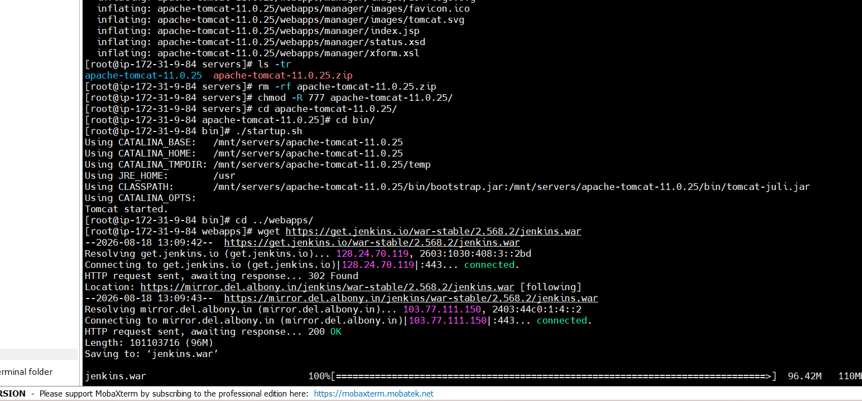
Step 2 – open Jenkins dashboard and create job using pipeline job and add code
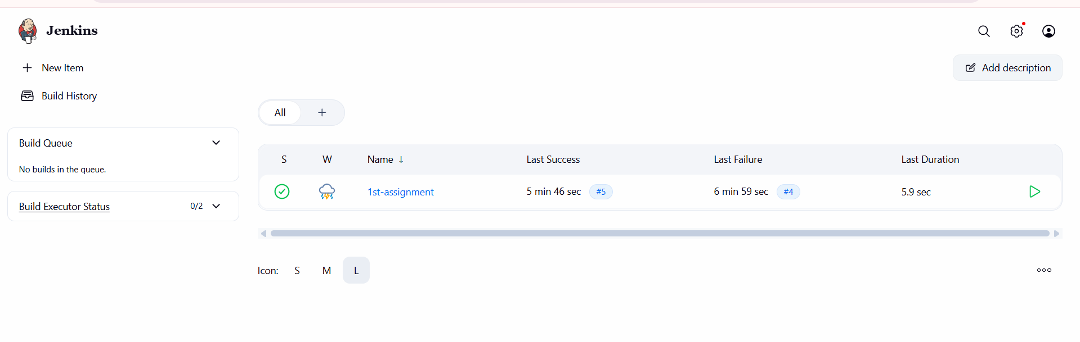
Add pipeline code
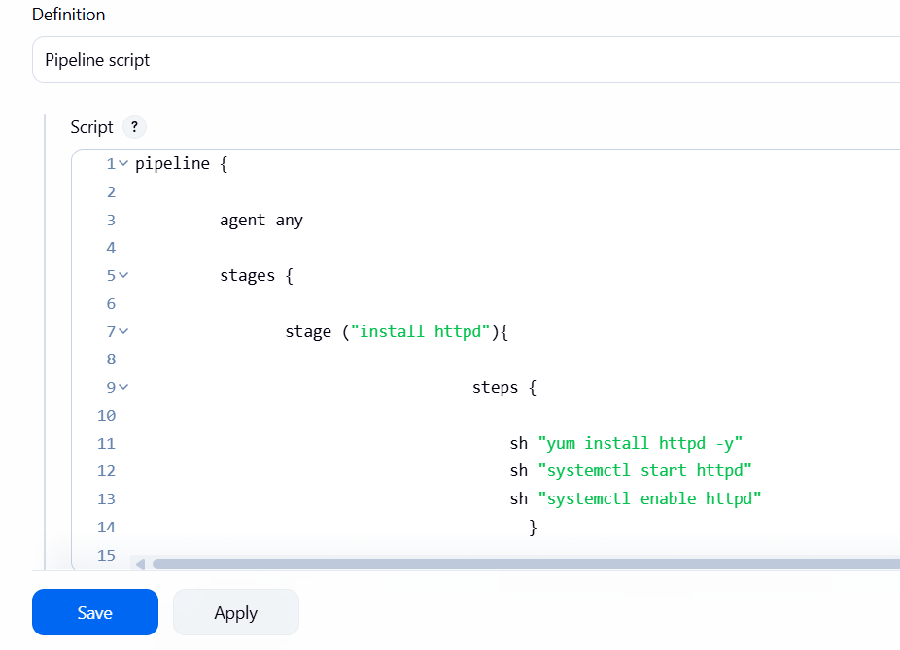
Add this full code
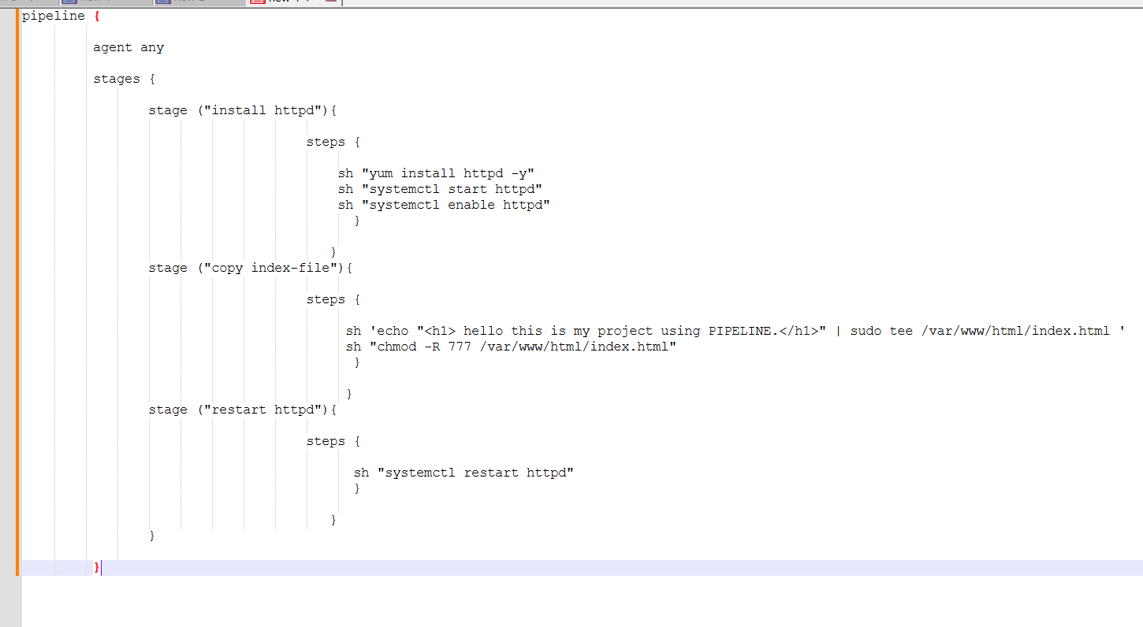
Step 3 – click on build now then check on browser like http://public ip
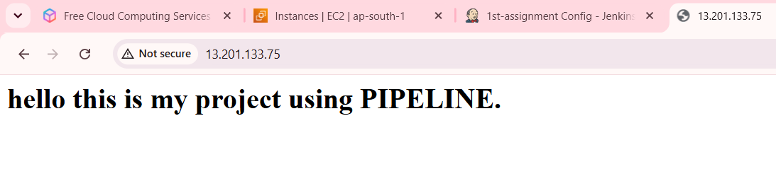
Done successfully .

